Feels

A project by Alejandro Barron, Daniel Gomez Calderon, and David Ellis

**Goal:** Create an app that delivers the user the latest and greatest wholesome memes. It also allows users to report on their stress levels, track them over time, and identify what most helps to reduce their stress (soothing background colors or music, certain types of memes, etc.).

**What It Does:** This is a site to relax and entertain people. Many people use Facebook solely for memes – this site will do exactly that. It will give people the latest and greatest *wholesome* memes.

**Why It’s Valuable:** Stress is a real issue. It is important to be conscious of its effect and act quickly to manage it. This allows us to continue to lead fulfilling and productive lives. This app will give users a tool to manage stress.

**Coding Tech and Goals:**

* React.
* Node and Express Web Server.
* MongoDB with Mongoose ORM.
* GET and POST routes for retrieving and adding new data.
* Heroku (with Data) for deployment
* Multiple libraries, packages, and technologies that we haven’t used in class, including:
  + X
  + Y
  + Z
* A polished frontend / UI
* A folder structure that meets MVC Paradigm
* Good quality coding standards (indentation, scoping, naming)
* Does not expose sensitive API key information on the server

**General Responsibilities by Individual:**

* Alejandra Barron
  + ***E.g. research, documentation, plan***
* Daniel Gomez Calderon
  + ***E.g. front end, ui, design***
* David Ellis
  + ***E.g. snacks, pizza, etc***

**Specific Responsibilities by Individual & Submission:**

* Deliverable #1 **Detailed Plan** (March 16)
  + [ALEX] Overview of the intended app, why it is valuable (this)

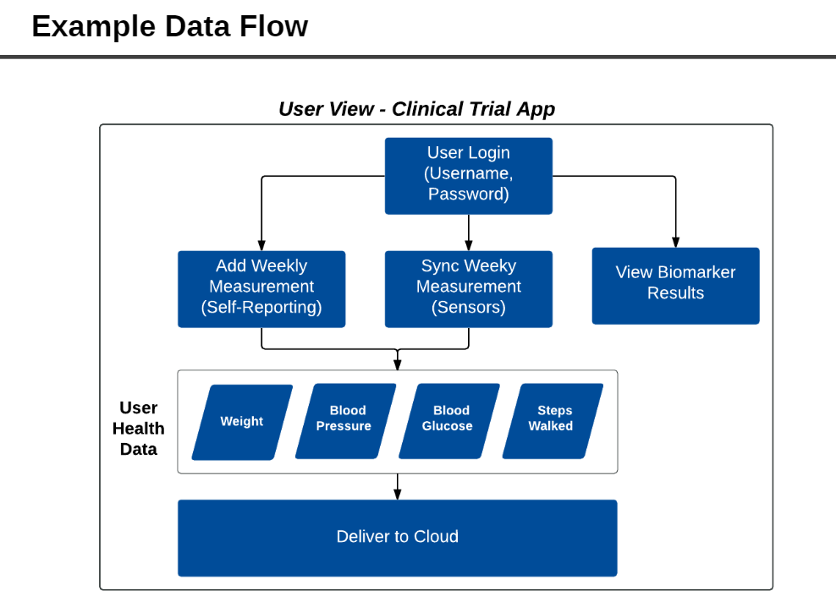

* + [DANIEL] Screen by Screen design layouts, with annotations describing all UI/UX components and all data relevant to the screen

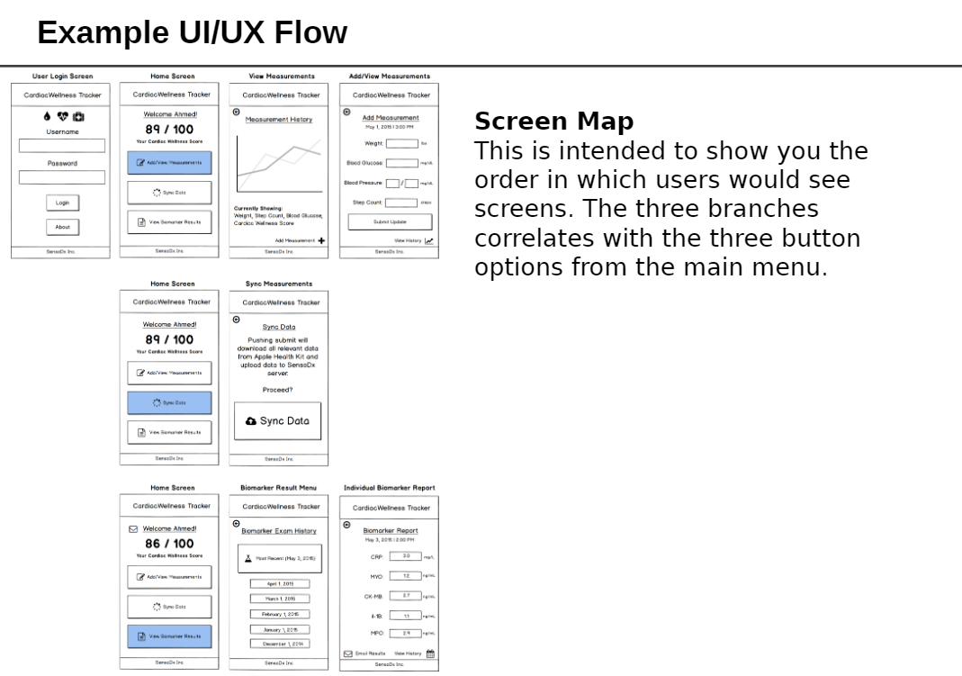

* + [DAVE] Breakdown of the roles by group member
  + [DAVE] Schedule for completion of various tasks (this document)
  + [DAVE] Screenshot of your Jira, Trello, or Project Management Board that shows breakdown of tasks – assigned to group members with a schedule
    - <https://trello.com/b/WN0NNaUX/du-final-project>
* Deliverable #2 **Ready MVP (Working App!), Mini Presentation** (March 23)
* Deliverable #3 **Polish, extra functionality, final plan** (March 30)
* Deliverable #4 **Presentation** (April 6)